INTERFAITH OF THE WOODLANDS ANNOUNCES 2024 HOMETOWN HEROES

January 19, 2024- The Woodlands, TX - Interfaith of The Woodlands is honored to announce the selection of the 2024 Hometown Heroes. The tradition of Hometown Heroes began in 1999, in celebration of The Woodlands 25th Anniversary. For this historic celebration of Interfaith’s 50th Anniversary, four individuals, a couple and two organizations have been named to the distinguished list of Heroes, each recognized in a unique way for the lasting impact they have made on The Woodlands community.

Roxanne Davis, Justin Kendrick, Nicole & Will Murphy, Dr. Mark Murrell, Ray Sanders,
The John Cooper School and Rotary of The Woodlands will officially join 162 other distinguished individuals, businesses and organizations as Hometown Heroes during The Woodlands Celebration of Excellence Gala, presented by Woodforest National Bank on Saturday, April 20, 2024. Recognized for their many contributions to the community, these honorees have each demonstrated exemplary leadership and a dedication to preserving Mr. George P. Mitchell’s vision for The Woodlands community.

The 2024 Hometown Heroes were announced last night at a gathering at The Woodlands Towers surrounded by family, friends and Hometown Heroes Alumni. The event venue was sponsored by Howard Hughes Corporation with food, drinks and decorations generously provided by Truluck’s The Woodlands and Piney Rose.

“Our community is full of amazing neighbors who, through their actions of service, make our community the best place to live, work, play and pray. These Heroes, nominated by our community, are chosen because they have made a positive impact, many for decades. We honor their commitment to The Woodlands area and are so excited to celebrate them at the Celebration of Excellence Gala in April, where each will receive their official Medallion,” shared Missy Herndon, President & CEO of Interfaith of The Woodlands.

Criteria for the selection of the Hometown Heroes includes: serving as a positive role model, having a history of volunteerism, sacrificing personal gain to achieve noble goals, exhibiting leadership and courage and embodying the values of The Woodlands community. Nominations were open to the community in the Fall, and presented to a selection committee comprised of previously awarded Hometown Heroes.

The Woodlands Celebration of Excellence Gala is the largest annual fundraiser for Interfaith of The Woodlands. Generously sponsored by many local businesses and organizations, all proceeds benefit Interfaith’s community Programs and Services. For sponsorship opportunities or individual tickets, please visit hometownheroesgala.org or contact Amanda Poole, Interfaith’s Director of Development, at development@woodlandsinterfaith.org or at 832-615-8225.

2024 HOMETOWN HEROES:

Roxanne Davis

Roxanne Davis, the long-serving community liaison lead for the Woodlands branches of the Houston Family YMCA, retired on December 22, after 30 years of service to the community. She began her relationship with YMCA after becoming a volunteer soccer coach for her son’s team.

She then began working part time as a marketing associate. The Woodlands was just starting to get its feet on the ground, and “The Y” became her family and community. It was here she found her purpose and passion.

Roxanne’s accomplishments include spearheading the beloved Thanksgiving Run Through the Woods, that boasts thousands of runners each year. She is also responsible for bringing the famous Dragon Boat races to The Woodlands and has led it every year since its inception.

Dr. Mark Murrell

Dr. Mark Murrell currently serves as principal of The Woodlands College Park High School. Dr. Murrell earned his Bachelor of Science degree in Mathematics from Stephen F. Austin State University. He got his first taste of education in 1991 as a Math teacher and coach in Texas City ISD. Mark found that he had a way of meeting students where they are and building them academically as well as socially and emotionally. He moved to the Conroe area in 1994 where he continued to teach and coach while beginning to work toward his goal of becoming an administrator. He worked to earn his Masters of Education in Administration from Sam Houston State University. He then continued his education by completing his Educational Doctorate in Executive Leadership in 2012.

Dr. Murrell transferred to Knox Junior High School as an assistant principal in 1996. He served as assistant principal for two and a half years before being named interim principal and ultimately principal. He served as principal of Knox JHS until 2003. He was honored to be named principal of The Woodlands College Park High School in February of 2004 which opened in 2005. This high school is where he found his home. Every day since then he has dedicated his time and energy to the students of College Park High School and their families. Through College Park High School, he has supported many nonprofit organizations including Interfaith of the Woodlands, Montgomery County Foodbank, Best Buddies, and Cassidy Joined for Hope and many others.

Dr. Murrell has also worked to help our community and fellow Texans as running a shelter during Hurricane Rita/Katrina within the first 6-weeks that College Park was opened. He organized food, water, and shelter for busload of people stranded on the nearby I-45. When no one could get to the school to help out, his family and some staff members that were able to get to the school and help run the shelter. Additionally, Mark managed a First Responders Staging area at College Park during Hurricane Ike. During Hurricane Harvey, College Park High School served as a shelter, medical assistance area, established an on-site pharmacy thanks to area physicians, and became home base for countless students and their families.

Mark and his wife, Tina are 30-year residents of The Woodlands. They proudly raised three sons, Todd, Blake, and Mark Alan in the area. Mark has dedicated his life to making our community the best place for his own family as well as many others.

Nicole & William Murphy

Will has served on Interfaith’s Board of Directors for the last 8 years, including two years as Chairman and is the current Board Ex-Officio. He is currently a Private Wealth Financial Advisor and Managing Director – Investments with Murphy Private Wealth Group of Wells Fargo Advisors. His background includes 20 years in the financial services industry and Private Wealth arena. Will holds a Masters of Business Administration from the University of New Orleans and is also a Certified Financial Planner (CFP). Will also serves on the Board of Directors for Beyond Batten Disease Foundation, Angel Reach, and is an Ambassador for Texas Children's Hospital. He and Nicole are also active volunteers at The Woodlands Christian Academy as Booster Club Co-Presidents. Additionally, Will has helped various charities doing live auctions and capital raises in excess of $20 Million over the last decade.

Nicole chaired more than a dozen golf tournaments and galas for The Will Herndon Fund for Juvenile Batten Disease Research. With a passion to serve, Nicole has given her time and support to many nonprofits in the area. Nicole is incredibly involved in her children’s school, and is a past chair of The Woodlands Christian Academy’s Color Run. Nicole is currently serving her third year on the Development Board at Interfaith, and has co-chaired the Giving Goes Glam fashion show and several Celebration of Excellence Galas, additionally she serves on the Women Empowering Women Committee for the Interfaith Community Clinic. Nicole spent six years serving through the National Charity League in Montgomery County alongside her daughter as well as chaired the NCL Senior Recognition. She is a former member of the Texas Children’s Hospital Advisory Council and a Lifetime Ambassador for TCH-The Woodlands. Presently, she is an active Circle of Red member and proud supporter of the American Heart Association. In addition to serving the philanthropies she loves, Nicole is a Realtor® with The Mike Seder Group in The Woodlands.

Will and Nicole are active members of The Woodlands Methodist Church and they have two children, Maddie 19 at Texas A&M University and Billy 14 at The Woodlands Christian Academy.

Justin Kendrick

Justin Kendrick serves as the Senior Vice President & CEO of Memorial Hermann The Woodlands Medical Center and Memorial Hermann Northeast Hospital. During his nine-year tenure with the Memorial Hermann Health System, he has served as Vice President of Operations at Memorial Hermann-Texas Medical Center and Memorial Hermann The Woodlands.

Justin received his bachelor’s degree in Business Administration from Southern Nazarene University and Master’s Degree in Healthcare Administration from Trinity University in San Antonio. He is a member of the American College of Healthcare Executives and serves on numerous community service and development boards including:

The Montgomery County Food Bank

Interfaith of The Woodlands

The Woodlands Area Economic Development Partnership

The Woodlands Area Chamber of Commerce

Partnership Lake Houston

A resident of The Woodlands, Justin and his wife, Chelsea, have three young children: Collins, Ellison and Brooks.

Ray Sanders

Ray Sanders and his wife, Karen, moved their family to south Montgomery County in July 1995, where they raised their daughters, with Olivia graduating from The Woodlands High School and Baylor University and his daughter, Ashley, graduating from the first class at The Woodlands College Park where Karen was employed with Conroe ISD and Texas A&M University.

Ray has been employed with Woodforest National Bank for more than 35 years in various positions and is celebrating his 40th year in bank in 2024. Today he serves on the Advisory Board for Interfaith of The Woodlands, and the Board of Directors for Interfaith Community Clinic, Mosaics of Mercy, and the Montgomery County Child Welfare Board. He is a member of Celebration Church in The Woodlands, where he serves as chair of benevolence and is a pastoral counselor.

Ray is also a Licensed Professional Counselor Supervisor and a National Board-Certified Counselor. His passions are education and community service. Ray served as a member of the Conroe Independent School District Board of Trustees for 12 years as Board President, Secretary and Audit Chair and has served as past Chairman of the Board for Interfaith of The Woodlands, The Woodlands Area Chamber of Commerce, and The Woodlands Economic Development Partnership. He is also a past Board member for Junior Achievement of Southeast Texas, South Montgomery County YMCA, Texas New Community Alliance, and the Gulf Coast Chapter of RMA.

Ray has a BBA in Finance and an MA in Counseling from Sam Houston State University. Ray has taught banking and finance classes for Sam Houston State University since 2010, and for the last three years has taught Strategic Marketing in the EMBA program. He has spoken professionally on topics of financial literacy, leadership, running businesses efficiently, communication skills, and personal financial management. Education and community service are his passions other than being a banker.

Ray has won the Woodlands Area Chamber Legacy Award for his service to The Woodlands community and in 2023 he won the Servant Leader Award from Leadership Montgomery County. He is also a Life Member of the Montgomery County Fair Association.

Ray lives his life by the motto of his alma mater, Sam Houston State University which says “The measure of a Life is its Service”. His wife has told him that on his gravestone will be the words “I was just trying to help”. He has dedicated himself to God, his family, his friends and his neighbors in that order.

The John Cooper School

The John Cooper School, founded within the vision of The Woodlands, Texas, is a community where scholarship, creativity, and curiosity prepare students to be leaders in a dynamic world. Honoring timeless traditions while embracing innovation, we intentionally equip our diverse group of students with future-minded skills and habits of success, inspiring them to lead a life of learning and purpose in the communities of which they will be a part.

Founded in 1988, Cooper serves as the premier independent school of The Woodlands. The John Cooper School is a non-sectarian, co-educational, college preparatory day school, serving Pre-Kindergarten through 12th grade, and boasts state-of-the-art facilities which promote collaborative learning.

The school’s mission is to provide a challenging education in a caring environment to a diverse group of select students, enabling them to become critical and creative thinkers, effective communicators, responsible citizens and leaders, and lifelong learners.

In keeping with Cooper’s whole-child philosophy, learning is valued in and out of the classroom, and we believe in fostering a community of responsible citizens and leaders. Cooper students abide by an Honor Code and affirm the values of honesty and integrity in an annual ceremony. Community service is deeply ingrained in our school’s ethos. Initiatives like partnering with Interfaith of The Woodlands showcase our students' commitment to social responsibility and community engagement. These projects allow our students to apply their learning outside the walls of their classrooms, reinforcing the School's mission of developing well-rounded individuals.

Under the leadership of Head of School Dr. Stephen Popp, The John Cooper School continues to flourish. A seasoned educator and school administrator with 25 years of experience in schools, Dr. Popp earned his Bachelor of Arts degree in History from Baylor University and earned a Master of Arts degree in History from the University of Houston as a James Madison Fellow. He also earned a Master of Education degree in Independent School Leadership from Columbia University. He completed his Doctorate in Education in Leadership, Learning and Organizations at Peabody College at Vanderbilt University, and his research focused on programs pertaining to mental health and well-being in Independent Schools. Currently, he serves on the board of the Nick Finnegan Counseling Center in Houston, Texas, the Montgomery County (TX) Food Bank, and the Heritage Museum of Montgomery County (TX).

Rotary Club The Woodlands

Rotary Club of The Woodlands was founded in 1975 as the first civic club in The Woodlands. Rotary Club of The Woodlands is a roughly 200-member local club of Rotary International, which is a global network of 1.4 million people of action who volunteer their skills and resources to solve issues and address community needs. Rotary has both a global emphasis and a local emphasis.

Rotary’s areas of focus are: Promoting Peace, Fighting Disease (Polio, etc.), Providing Clean Water, Helping Mothers/Children, Supporting Education, Growing Local Economies, Protecting the Environment, and also Disaster Response. Rotary has the motto “SERVICE ABOVE SELF”.

Rotary Club of The Woodlands has helped The Woodlands in so many ways, from engaging and promoting literacy with local youth, to assisting and celebrating with seniors in our area.They have donated toward worldwide eradication of Polio, provided scholarships for area high school seniors and Lone Star College Montgomery students, sponsored INTERACT Clubs in the area High Schools, established ROTARY HOUSE in The Woodlands area in 2017, as a separate 501C3 nonprofit, offering a low-cost place to stay for out-of-town patients and families while they are receiving medical treatment in The Woodlands Medical Center, quarterly Blood Drives, Youth Exchange for several years, inbound and/or outbound. They also serve in world community service projects that vary from year to year.

About Interfaith of The Woodlands:

Interfaith of The Woodlands is a non-profit social service agency providing numerous programs and services to meet the needs of The Woodlands and surrounding area. For more information on Interfaith’s programs and services, or to become a volunteer, please visit: woodlandsinterfaith.org or call 281-367-1230.

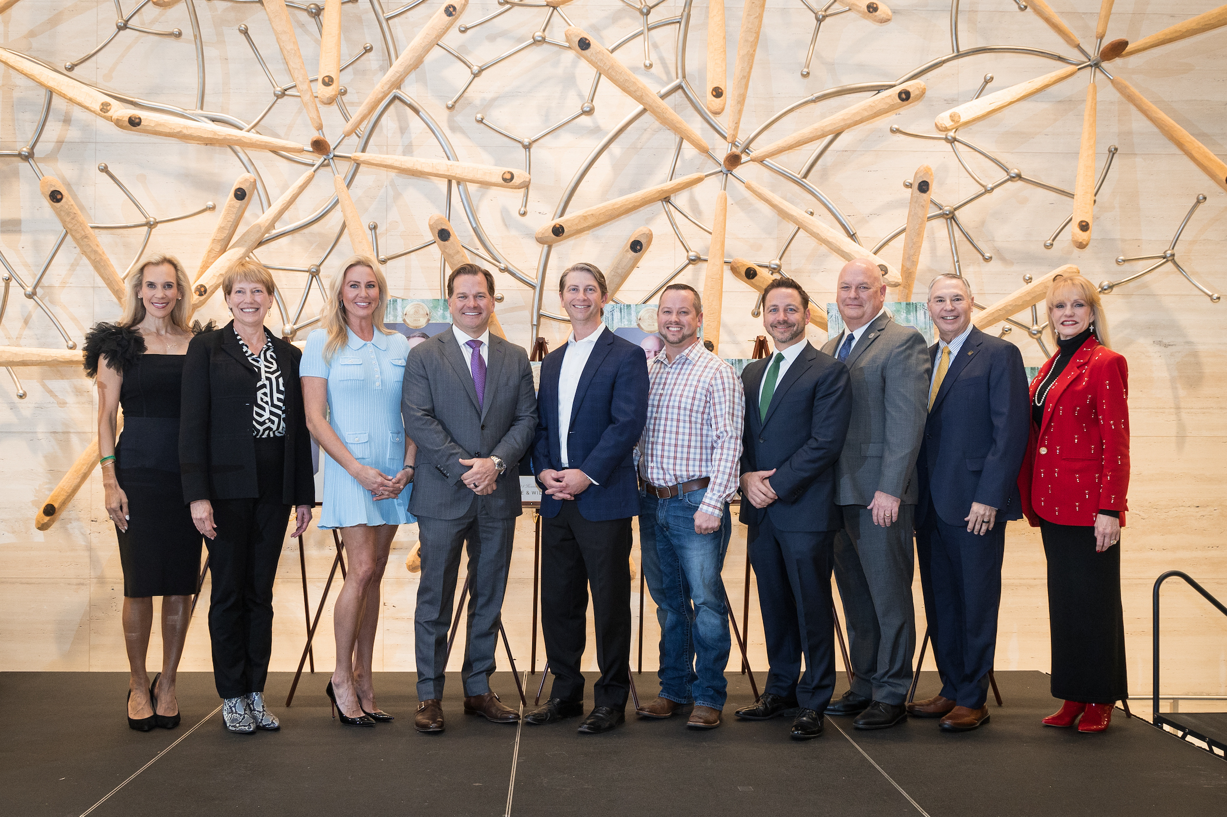

Photo Cutline: Pictured left to right- Missy Herndon, President and CEO of Interfaith of The Woodlands, Kay Boehn-Fannin, Nicole Murphy, Will Murphy, Justin Kendrick, Andy Davis, Dr. Stephen Popp, Dr. Mark Murrell, Ray Sanders, and Nelda Blair.

